Roll No-12

M.sc. 3rd semester

Date of Assignment-21/12/2020

Date of Submission-12/01/2021

**Experiment No -11**

**Topic**-**-** Fitting of Auto Regression (AR) series to time series data.

**Problem** –**-** Fit a auto regressive series of order 2 from the following data.



|  |  |
| --- | --- |
| t | ut |
| 1 | 7 |
| 2 | 6 |
| 3 | -6 |
| 4 | -4 |
| 5 | 3 |
| 6 | -4 |
| 7 | -5 |
| 8 | -8 |
| 9 | 10 |
| 10 | 10 |
| 11 | 6 |
| 12 | -4 |
| 13 | -4 |
| 14 | -7 |
| 15 | -2 |
| 16 | 6 |
| 17 | 17 |
| 18 | 24 |
| 19 | 13 |
| 20 | 1 |
| 21 | 1 |

Also find the period of the auto regressive series of order 2.

**Theory and Calculation**-

Fitting of AR(2)

The auto regressive series of order k is given by –



Now, taking the deviation of the observations ut from their mean and replacing the ut’s with these deviations, the series becomes



When, k=2, the AR series of order k reduces to

 -------(1)

Multiplying eqn by  , we get

 ---------(2)

Taking expectation on both sides of equation (2) we get-



 -------(3)

Where,  represents the auto-covariance function at lag k. Dividing both sides by  , we get from (3)

 --------(4)

Where  represents the autocorrelation at lag k.

**[** When k=3, the AR reduces to

 ------(5)

Multiplying both sides of eqn (5) by  and taking expectation, we get—



 -----(6)

Dividing both sides of eqn (6) by  , we get—



 ------(7) **]**

In practice,  is determined by the sample counter part of  i.e. . Putting k = 1 and k = 2 in eqn (4) we get-



And



Replacing  &  by  and  respectively, we get -







 -------(8)

Solving (8) , we get the estimate of the coefficients  ‘s . Therefore the fitted AR series of order 2 is-



The period of the fitted second order AR series is given by-



Finally, we have -





**Calculation-**

we construct the following table-

|  |  |
| --- | --- |
| t | ut |
|  |  |
| 1 | 0 |
| 2 | 0 |
| 3 | 4.66925 |
| 4 | -4.96459 |
| 5 | 2.265444 |
| 6 | 7.23029 |
| 7 | -1.89507 |
| 8 | 0.499542 |
| 9 | -1.56221 |
| 10 | 14.96881 |
| 11 | 6.647786 |
| 12 | 3.282412 |
| 13 | -3.28191 |
| 14 | 1.340886 |
| 15 | -1.18315 |
| 16 | 4.41041 |
| 17 | 8.829762 |
| 18 | 14.38631 |
| 19 | 15.19064 |
| 20 | 2.699908 |
| 21 | -2.31114 |

**Programming in R**

library(readxl)

df_1 = read_excel("Autocorrelation_3.xlsx")

View(df_1)

ut=c(7,6,-6,-4,3,-4,-5,-8,10,10,6,-4,-4,-7,-2,6,17,24,13,1,1)

Mean=mean(ut)

Mean

N=length(ut)

N

#Calculation of sample auto-covariance and auto-correlation at lag1 and lag2

c0=var(ut)*((N-1)/N)

c0

c_k=mat.or.vec(2,1)

r_k=mat.or.vec(2,1)

for(i in 1:2){

c_k[i]=(sum((ut[1:(N-i)]-Mean)*(ut[(1+i):N]-Mean)))/N

r_k[i]=c_k[i]/c0

}

c_k

r_k

#auto-covariance at lag1 and lag2

cov1=c_k[1]

cov2=c_k[2]

#auto-correlation at lag1 and lag2

r1=r_k[1]

r2=r_k[2]

#Calculation of coefficients phai1 and phai2

A=array(c(r1,r2),dim=c(2,1))

B=array(c(1,r1,r1,1),dim=c(2,2))

coeff=solve(B)%*%A

coeff

phai_1=coeff[1,1]

phai_1

phai_2=coeff[2,1]

phai_2

#Calculation of period of AR(2) process

theta=acos(phai_1/(2*sqrt(abs(phai_2))))

theta

pi=22/7

period=(2*pi)/theta

period

#Here, in R propgram pi represents 22/7 value

#Calculation of 1st and 2nd term of our fitted AR(2) model

first_term=phai_1*ut[2:20]

second_term=phai_2*ut[1:19]

ut_des_est=first_term+second_term

ut_des_est

ut_est=ut_des_est+Mean

ut_est

df_a = append(0,ut_est)

df_2 = append(0,df_a)

View(df_2)

Data = cbind(df_1,df_2)

Data

#using ggplot to plot the graph

library(ggplot2)

ggp = ggplot(NULL, mapping = aes(t)) +

geom_point(data = Data, mapping = aes(y=ut), col = "black") + geom_line(data = Data, mapping = aes(y=ut), col = "orange", size = 1) +

geom_point(data = Data, mapping = aes(y=df_2), col = "blue") + geom_line(data = Data, mapping = aes(y=df_2), col = "green", size = 1) +

labs(

title = paste("Plotting of observed ut and estimated ut against t"),

subtitle = paste("orange_line=observed ut and green_line=estimated ut"),

caption = "Data from Model",

x = "t",

y = "observed_ut_and_estimated_ut"

)

ggp

**Graph plotting**

We plot the graph of observed and estimated values for the second order series considering t along X-axis and  &  along Y-axis by Using ggplot2-

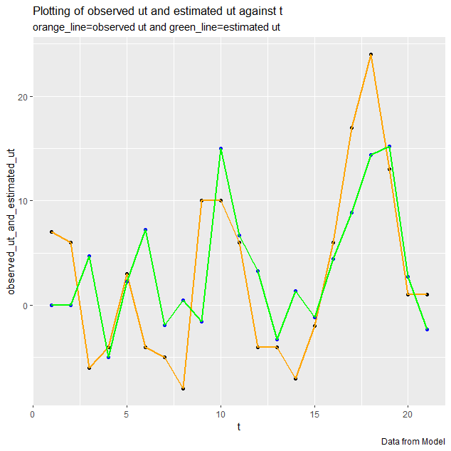

**Tableau-**

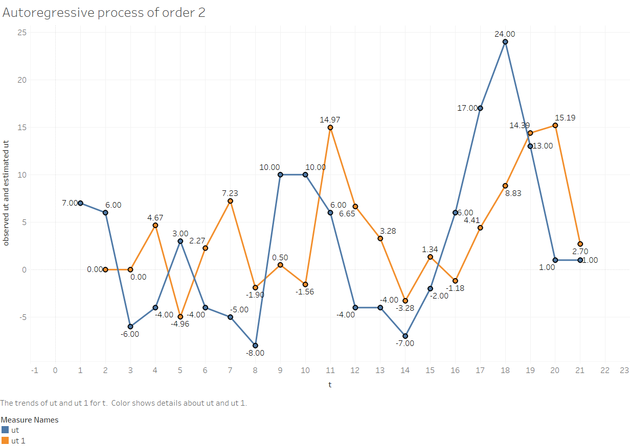

**Conclusion-**

The fitted AR(2) is-



Hence, The period of the fitted AR series of order 2 is 6.955614.